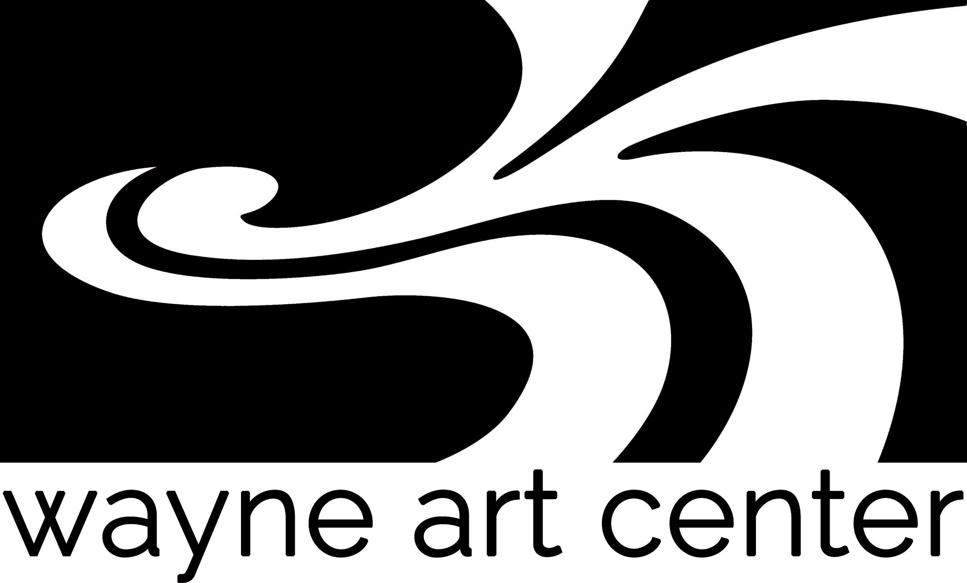
FOR IMMEDIATE RELEASE
Contacts:
Nancy Campbell, Executive Director
610-688-3553 x 204
nancy@wayneart.org
Patti Hallowell, Exhibitions Coordinator
610-688-3553 x. 211
patti@wayneart.org

WAYNE ART CENTER CELEBRATES THE ARTISTIC TALENTS OF RADNOR TOWNSHIP RESIDENTS THROUGH EXPRESSIONS OF RADNOR

WAYNE, PA – January 15, 2019 − Wayne Art Center presents Expressions of Radnor, an annual exhibition that showcases the talent of Radnor residents in all media, on view from February 19 through March 16, 2019. Awards will be presented by juror Stephanie Lieberman during the Opening Reception on Sunday, February 24, from 3 to 5 p.m., where visitors are invited to meet the artists and observe the works. The Opening Reception and Exhibition are free and open to the public.
Stephanie Lieberman is an award-winning landscape and animal painter, and a graduate of the Pennsylvania Academy of Fine Arts. She enjoys wide gallery representation throughout the United States and has been featured in numerous publications including American Art Collector and Atlanta Style & Design.

“Expressions of Radnor is one of my favorite exhibits at Wayne Art Center, because it lets us connect directly with Radnor artists and brings members of our immediate community together to celebrate them,” says Nancy Campbell, executive director of Wayne Art Center. “Because our large, light-filled galleries present work so beautifully, many artists enter Expressions in Radnor year after year. It’s exciting to see how artists grow and work changes over time.”
Expressions of Radnor is open to all artists who are legal residents of Radnor Township. Artists are eligible to submit up to two pieces of original artwork in any medium, including oil or acrylic painting, watercolor, pastel, photography, printmaking, mixed media, ceramics, stained glass or sculpture. The entry fee is $10.00 per piece and covers administrative and installation costs.

Artists should drop off entries at Wayne Art Center on Friday, February 8 from 9:00 am – 7:00 pm or Saturday, February 9 from 9:00 am – 4:00 pm. For more information or to receive a prospectus please call Wayne Art Center at 610.688.3553 or visit the website at www.wayneart.org/exhibitions.

Established in 1930 as the first art center on the Philadelphia Main Line. Wayne Art Center offers instruction for all ages in the visual, performing and culinary arts. Each year, nearly 5,000 students enroll in 500 classes and workshops, and more than 1,500 children register for our Summer Arts program. We are proud to serve students in the greater Main Line area, including Delaware, Chester and Montgomery counties. Our exhibitions, lectures, and gallery shop attract more than 15,000 visitors annually.

