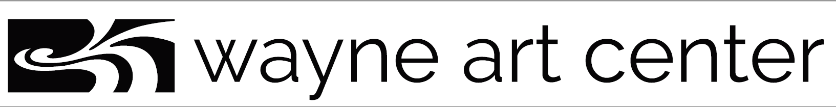

Private Art Pod Student Registration Form

Art Pod lesson Pricing:
$125. Per member student per 1.5 hour classes x4
$145. Per non-member student per 1.5 hour classes x4

All private pod classes must be paid for in advance. A minimum of 24 hour notice is required prior for cancellation by student. Cancellations are non-refundable.

Name: ____________________________________________________________
Address: __________________________________________________________
Email: _____________________________________________________________
Phone; ____________________________________________________________
Media Type: ________________________________________________________
Teacher: ___________________________________________________________
Group Contact Parent: ________________________________________________
Child’s School: ______________________________________________________

Class Dates and Times
Date: ___________________________ Time: _____________________________
Date: ___________________________ Time: _____________________________
Total hours: ______________________ Membership: _______________________

